How to connect your Q Station to your home network

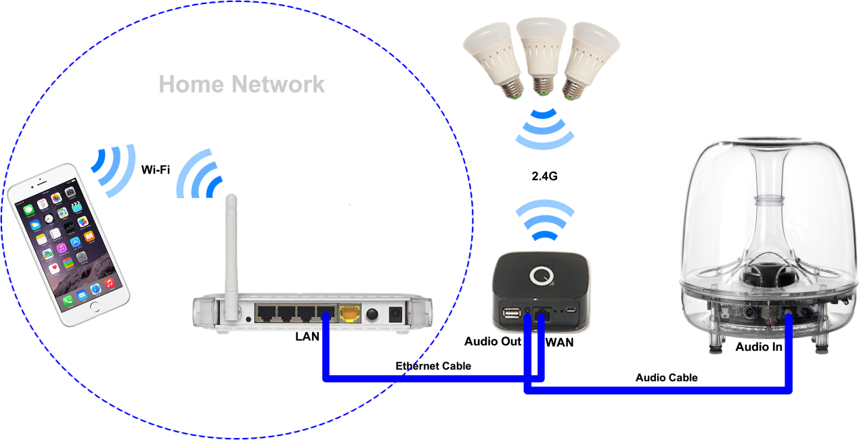
1. Plug Ethernet cable one end to you regular router (use one of the LAN ports in the back) and the other end to Ethernet port of Q Station

2. Plug audio cable from 2.5 mm Jack of your Q Station to your audio system.

